Is curing cannabis always necessary?

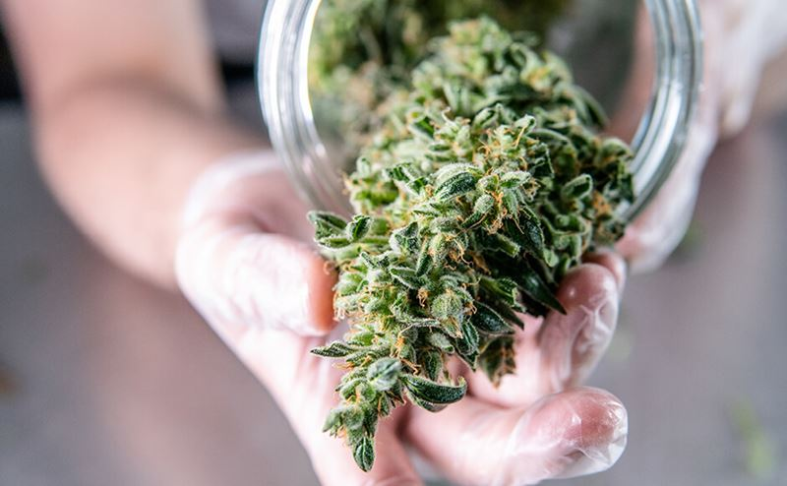There are different ways to cure cannabis once it’s been harvested, and which is best depends on how it is to be consumed and personal preference.
Some popular methods of storing and preserving cannabis post-harvest:

Fresh Frozen: No drying, no curing
Some people, who like concentrates, prefer to work with cannabis that was immediately frozen after harvest. The material is rough trimmed while wet, then placed into containers, and then into a freezer. This method eliminates the drying and curing steps, but is not great for cannabis you intend to smoke.
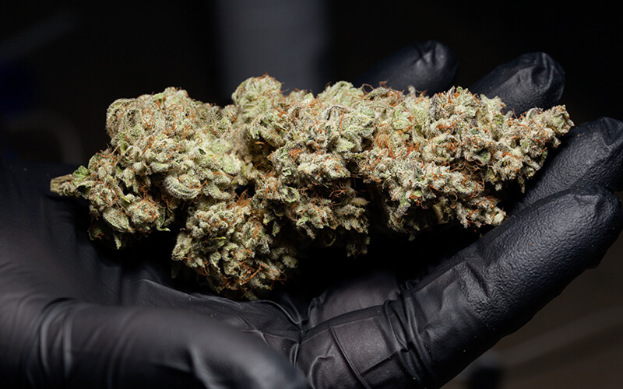
Source: Maximum Yield
Post-harvest: The care and treatment of cannabis after harvest has a big impact on the quality and properties of the final product.

Water Cure: Cure without first drying
Water-curing is when cannabis is cured without being dried first. The cannabis is placed in a container with clean water. The water is changed with fresh water a few times a day for 5 to 7 days. This will leech out the water-soluble components through osmosis. Since the concentration of these components is higher inside the plant than in the water, they will move from inside the plant material to try to equalize with the concentration in the water. Changing the water with fresh water keeps the concentration low and encourages movement out of the plant into the water.
Even though the aromatic oils (terpenes) are not water-soluble, they are reduced as they are lighter than water, and the force of being submerged causes them to float to the top where they are removed when changing the water. Then the cannabis is hung and dried before use or storage.
Properly water-cured cannabis is some of the smoothest smoke available, if that is how you chose to use it. It is so smooth that many find the flavour (what little there is left) to be flat.
Well-made, water-cured cannabis doesn’t have much flavour, although the potency is still present. This is great if smoking in stealth is a concern (the smoke has little if any conventional cannabis aroma), or when used in edibles.
After decarboxylation (using low heat to drive off carbon dioxide from THC-A to convert it to THC), water-cured cannabis is so mild tasting it can be simply ground and used directly in cooking. When made into cannabutter or infused oils, it lacks the distinctive cannabis flavour that many dislike in edibles.
Note: even if done correctly, the “bag appeal” is severely reduced. The buds appear inferior and mistreated even if they haven’t been.
If water changes are not performed, the material can be ruined by sitting in stale water. If not dried properly after the rinsing, it can get mouldy.
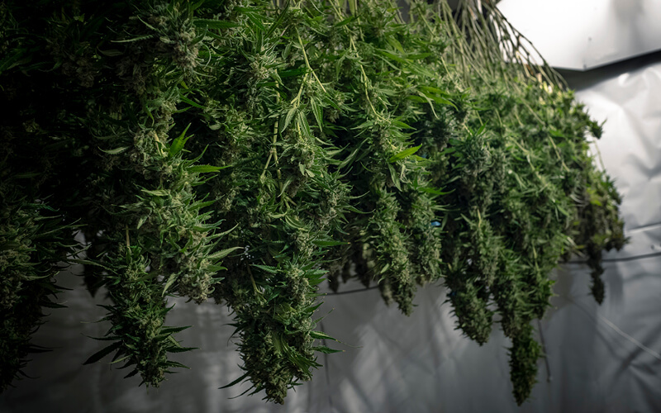
Some cannabis is dried and not allowed to cure before use.
Source: OpenRangeStock/Shutterstock

Hurried and Harsh: Dry only, no cure
Besides the above methods, cannabis is usually dried before use. Freshly harvested is too moist to be stable and will mould unless much of the moisture is removed. So, immediately after harvest, the cannabis is dried in the open air until enough moisture has evaporated to prevent fungal growth, but not so much that it loses structural integrity. Drying is best done under mild conditions - too wet and cold can delay drying enough to be a mould risk - too hot and dry can cause the outer portions to over-dry while the interior flowers and stems are still too wet to be stored.
Some cannabis is dried and not allowed to cure. This is commonly seen from commercial farms or novice growers. The smoke is harsher when compared with a properly cured bud from the same plant. But, dried but uncured cannabis is more popular than having no cannabis at all, so it is frequently used in times of urgency or need.

The Conventional Method: Dry then cure
Conventional, properly cured cannabis is dried as above, then put into airtight containers and kept in a cool, unlit place to allow the buds to mature and cure over a few weeks or months. If the cannabis was correctly dried to the right amount, it will be dry enough to prevent mould but still have enough moisture to cure properly. Erring on the side of dry is better than it being too wet.
In the beginning, the jars are opened and checked. At any sign of excess moisture, the buds are removed and allowed to dry more before returning to sealed jars. For smaller adjustments, the lid can be removed until a more acceptable moisture level is reached (burping).
A hint of ammonia in the aroma means the cannabis is too wet and is starting to spoil, and a strong ammonia smell or visible mould means that the cannabis was much too wet and has been ruined.
The right cure can have a big influence on whether the end product is delightful or just mediocre.
Source: Maxiumum Yield

